# The Analysis Report of Majors and Occupations Preference of 2025 DSE Students

**San Wui Commercial Society Secondary School**

The following summary report presents the major findings extracted from the survey results collected by San Wui Commercial Society Secondary School, including students’ major and occupation preferences, the influence of STEM education and Greater Bay Area (GBA) development on their preferences, and students' approaches to stress management. (Total respondents: 29)

* **Majors Preference**

|  |  |  |  |
| --- | --- | --- | --- |
| Rank | **Popular Majors** | **Male Popular Majors** | **Female Popular Majors** |
| 1st | Sociology | Artificial Intelligence (AI) | Sociology |
| 2nd | Risk Management | Computer Engineering | Economics |
| 3rd | Economics | Risk Management | Survey |
| 4th | Survey | Mechanical / Electrical | Human Resources |
| 5th | Artificial Intelligence (AI) | Property Management | Public Health |

|  |  |
| --- | --- |
| Rank | **Unpopular Majors** |
| 1st (=0) | History |
| 2nd (=1) | Chemistry |

[LLM OUTPUT PLACEHOLDER]

* **Occupations Preference**

|  |  |  |  |  |
| --- | --- | --- | --- | --- |
| Rank | **Popular Occupations** | **Male Popular Occupations** | **Female Popular Occupations** | |
| 1st | Start-up Business | Biomedical | | Advertising |
| 2nd | Biomedical | Mechanical Engineering | | Start-up Business |
| 3rd | Asset Management / Stock | Start-up Business | | Chef |
| 4th | Chef | Specialist | | Civil |
| 5th | Psychologist | Asset Management / Stock | | Civil Servant (Clerical) |

|  |  |  |
| --- | --- | --- |
| Rank | **Unpopular Occupations** |  |
| 1st (=0) | Specialist | |
| 2nd (=1) | Information Technology (IT) | |

[LLM OUTPUT PLACEHOLDER]

* **Influence of STEM Education**

***(Results analyzed from the average of STEM participants and non-STEM participants)***

|  |  |  |
| --- | --- | --- |
| **Effectiveness of STEM Project** | **Strongly Improve** | **Partially Improve** |
| **Leadership** | 9.1% | 45.5% |
| **Teamwork** | 27.3% | 63.6% |
| **Creative Thinking** | 18.2% | 63.6% |
| **Science Knowledge and Understanding** | 27.3% | 54.5% |
| **Problem Solving Skills** | 9.1% | 72.7% |

|  |  |  |  |  |  |
| --- | --- | --- | --- | --- | --- |
| **STEM Majors Preference** | **Have attended STEM**  **(A=14 )** | | **Have not attended STEM**  **(A=15)** | **Difference** |  |
| **Engineering** | 21.4% | 20.0% | | 1.4% |  |
| **Science** | 28.6% | 26.7% | | 1.9% |  |
| **Total** | 50.0% | 46.7% | | 3.3% |  |

**\**Engineering* majors include Computer Engineering, Mechanical/Electrical, Aviation Engineering and Science Engineering\***

**\**Science* majors include Physics, Chemistry, Biology, Biochemisty, Environmental Science, Mathematics, Statistics, Actuarial, Computer Science and Artificial Intelligence (AI)\***

|  |  |  |  |  |  |
| --- | --- | --- | --- | --- | --- |
| **STEM Occupations Preference** | **Have attended STEM**  **(A=14)** | | **Have not attended STEM**  **(A= 15)** | **Difference** |  |
| **Engineering** |  |  | |  |  |
| **Science** |  |  | |  |  |
| **Total** |  |  | |  |  |

**\**Engineering* occupations include Computer Engineering, Mechanical/Electrical, Aviation Engineering, Science Engineering, Manufacturing\***

**\**Science* occupations include Information Technology, Data Science, Artificial Intelligence, Biochemistry, Laboratory, Environmental Science\***

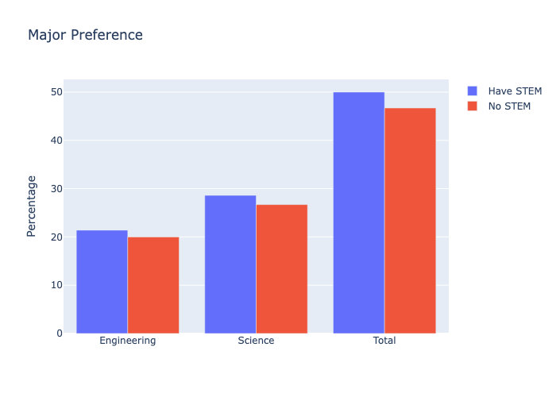

* **Influence of Greater Bay Area Development Policy**

***(*Results analyzed from respondents with high GBA familiarity and respondents with low familiarity)***

|  |  |  |  |
| --- | --- | --- | --- |
| **GBA Majors Preference** | **Familiar with GBA** | **Unfamiliar with GBA** | **Difference** |
| **Business** | 68.8% | 46.2% | 22.6% |
| **Science** | 6.2% | 53.8% | -47.6% |

**\**Business* majors include Accounting, Aviation management, Economics, Finance, Logistics, Hotel & Tourism Management, Human Resources, Investment, Managment, Marketing, Risk Management, Property Management)**

**\**Science* majors include Physics, Chemistry, Biology, Biochemistry, Environmental Science, Mathematics, Statistics, Actuarial, Computer Science, Artificial Intelligence)**

|  |  |  |  |
| --- | --- | --- | --- |
| **GBA Occupations Preference** | **Familiar with GBA** | **Unfamiliar with GBA** | **Difference** |
| **Business** |  |  |  |
| **Engineering** |  |  |  |
| **Science** |  |  |  |

**\**Business* occupations include Advertising, Administrative/Management, Asset Management/Stock, Banking/Finance, Hospitality/Tourism, Human Resources, Insurance, Property/Real Estate, Risk Management, Start-up Business\***

**\**Engineering* occupations include Computer Engineering, Mechanical/Electrical, Aviation Engineering, Science Engineering, Manufacturing**

**\**Science* occupations include Information Technology, Data Science, Artificial Intelligence, Biochemistry, laboratory, Environmental Science\***

* **Appendix**
* **Majors Preference (Top 7 Ranking)**

|  |  |
| --- | --- |
| Rank | **Popular Majors** |
| 1st | Sociology |
| 2nd | Risk Management |
| 3rd | Economics |
| 4th | Survey |
| 5th | Artificial Intelligence (AI) |
| 6th | Game Design |
| 7th | Mathematics |

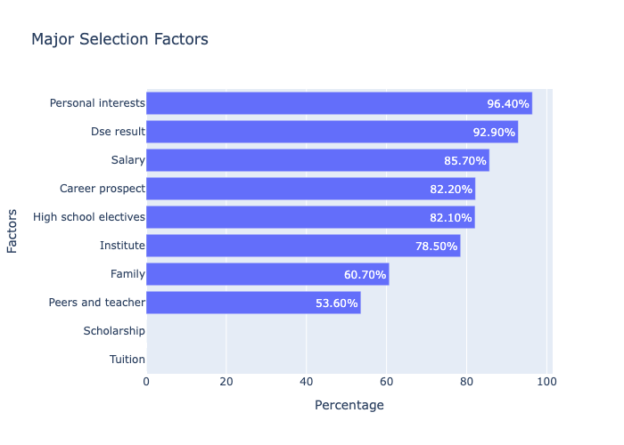

**Occupations Preference (Top 7 Ranking)**

|  |  |
| --- | --- |
| Rank | **Popular Occupations** |
| 1st | Start-up Business |
| 2nd | Biomedical |
| 3rd | Asset Management / Stock |
| 4th | Chef |
| 5th | Psychologist |
| 6th | Digital Marketing |
| 7th | Banking / Finance |

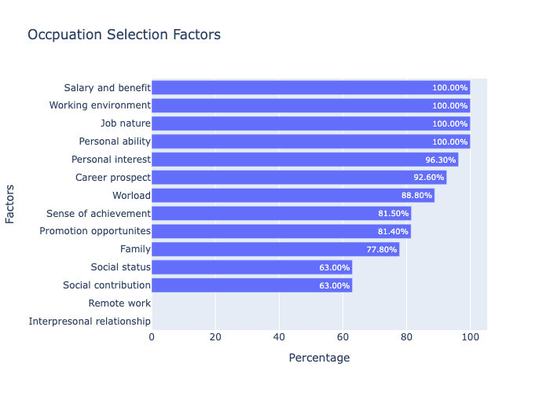

* **Stress Factor**

|  |  |  |  |
| --- | --- | --- | --- |
| **Factor** | **Individual School** | **General** | |
| Personal | 63.0% | | 60.9% |
| External | 37.0% | | 38.9% |

* **Sources**

|  |  |  |  |
| --- | --- | --- | --- |
| **Sources** | **Individual School** | **General** | |
| Parent’s Expectation | 37.9% | | 42.4% |
| Peer Comparison | 37.9% | | 36.4% |
| Tight Study Schedule | 24.1% | | 39.1% |
| Examination Results | 82.8% | | 74.0% |
| Relationships | 20.7% | | 18.2% |
| Own Prospect | 55.2% | | 61.8% |
| Own Expectation | 44.8% | | 61.5% |
| Covid-19 | 13.8% | | 7.4% |
| Long Time Alone | 10.3% | | 8.6% |
| Changing Exam Time | 0.0% | | 7.0% |
| Unstable School Time | 0.0% | | 8.2% |

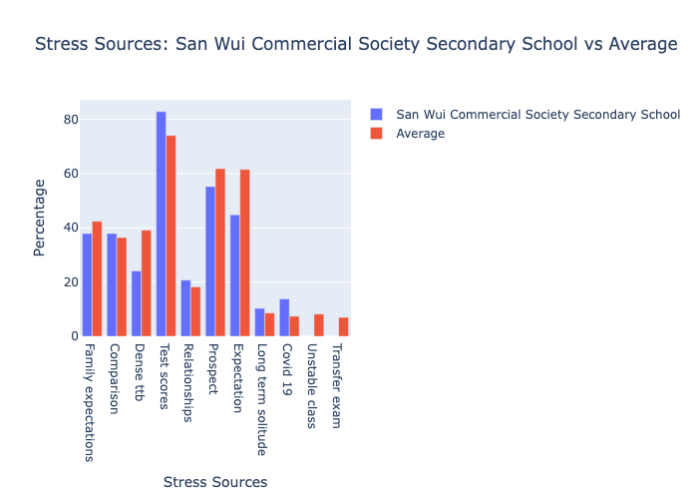

[LLM OUTPUT PLACEHOLDER]

* **Stress Levels**

|  |  |  |  |
| --- | --- | --- | --- |
| **Level** | **Individual School** | **General** | |
| None | 0.0% | | 3.1% |
| Very Low | 3.6% | | 3.0% |
| Low | 0.0% | | 9.7% |
| Moderate | 35.7% | | 27.1% |
| High | 42.9% | | 28.6% |
| Very High | 17.9% | | 28.5% |

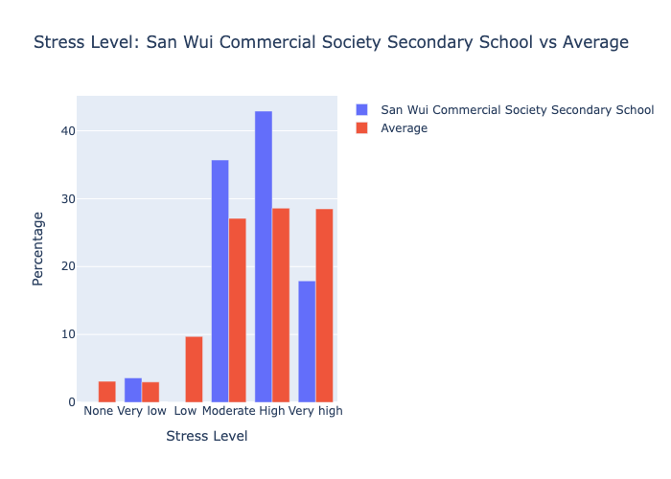

* **Endure Stress**

|  |  |  |  |
| --- | --- | --- | --- |
| **Endure Level** | **Individual School** | **General** | |
| Totally cannot | 71.4% | | 65.0% |
| Mostly cannot | 7.1% | | 11.7% |
| Mostly can | 21.4% | | 17.7% |
| Totally can | 0.0% | | 5.5% |

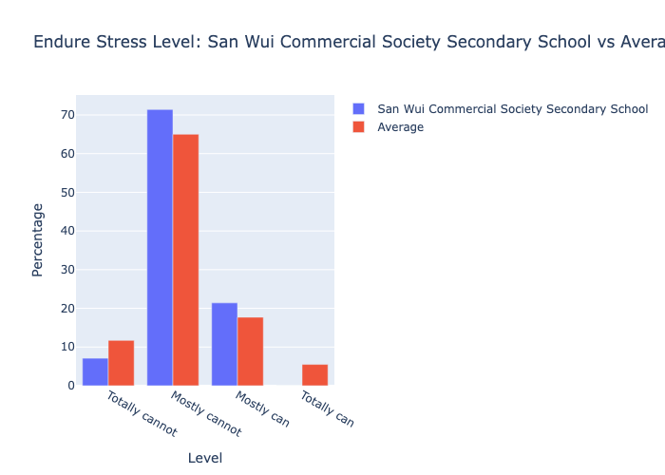

* **Stress Management**

|  |  |  |  |
| --- | --- | --- | --- |
| **Method** | **Individual School** | **General** | |
| Do Exercise | 34.5% | | 28.6% |
| Communicate with Family | 20.7% | | 16.4% |
| Communicate with Friends | 41.4% | | 39.5% |
| School Counsellor | 0.0% | | 5.5% |
| Reschedule Timetable | 10.3% | | 10.1% |
| Sleep | 44.8% | | 41.0% |
| Computer Games | 75.9% | | 64.2% |
| Listen to Music | 65.5% | | 62.3% |
| No Idea | 3.4% | | 11.3% |

